Certificate of Analysis

General properties:
Name： FITC-PEG1000-SH
Molecular Weight： 1000 Dalton
Cat.#： R-01014
Lot.#： 785414
Manufacture Date： 2016.01.15
Date of Analysis： 2016.01.15
Recommended Retest date： 2017.01.15
Stability： 12 months
Storage： -20°C in the dark

Structure

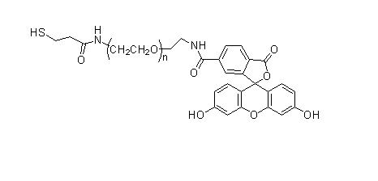
Items | Specification | Results
Appearance | Yellow solid | Yellow solid
¹H NMR | Identical to the structure | Identical to the structure
Foreign Material | None | None
Substitution | ＞90% | 90%
Report Date: 2016.01.15

This product is for research use only, Not for human or animal use

